DSM2 Data Augmentation Studies

Changes to Sacramento and San Joaquin River Inflows

INPUTS: Augmentations to DSM2 Inflow Timeseries

| **#** | **Scenario Alias** | **Description** |
| --- | --- | --- |
| 1 | RSACMINUS15DAY | Shift Sacramento River inflows (RSAC155) forward by 15 days |
| 2 | RSACPLUS15DAY | Shift Sacramento River inflows (RSAC155) backward by 15 days |
| 3 | RSACMINUS20PCT | Scale Sacramento River inflows (RSAC155) down by 20% |
| 4 | RSACPLUS20PCT | Scale Sacramento River inflows (RSAC155) up by 20% |
| 5 | RSANMINUS15DAY | Shift San Joaquin River inflows (RSAN112) forward by15 days |
| 6 | RSANPLUS15DAY | Shift San Joaquin River inflows (RSAC112) backward by 15 days |
| 7 | RSANMINUS20PCT | Scale San Joaquin River inflows (RSAC112) down by 20% |
| 8 | RSANPLUS20PCT | Scale San Joaquin River inflows (RSAC112) up by 20% |

Notes:

Augmentations relative to historical timeseries  
Martinez EC Generator re-run for each scenario

Figure 1: Augmented Inflow Timeseries for Sacramento

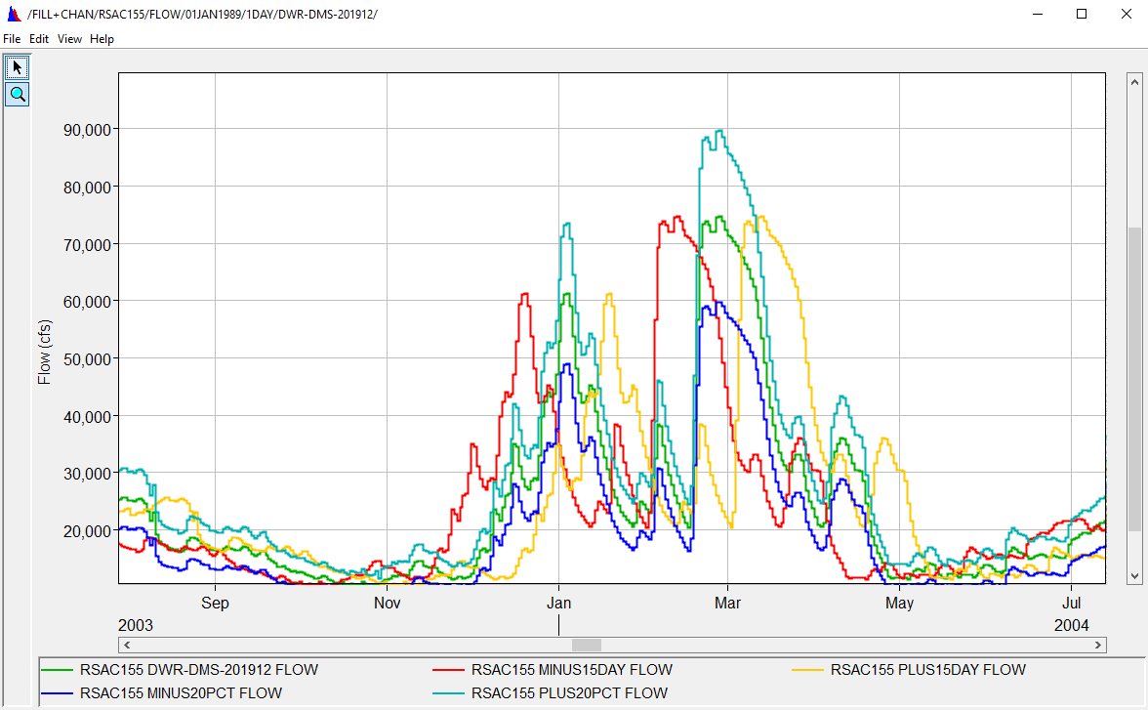

Figure 2: Augmented Inflow Timeseries for San Joaquin River

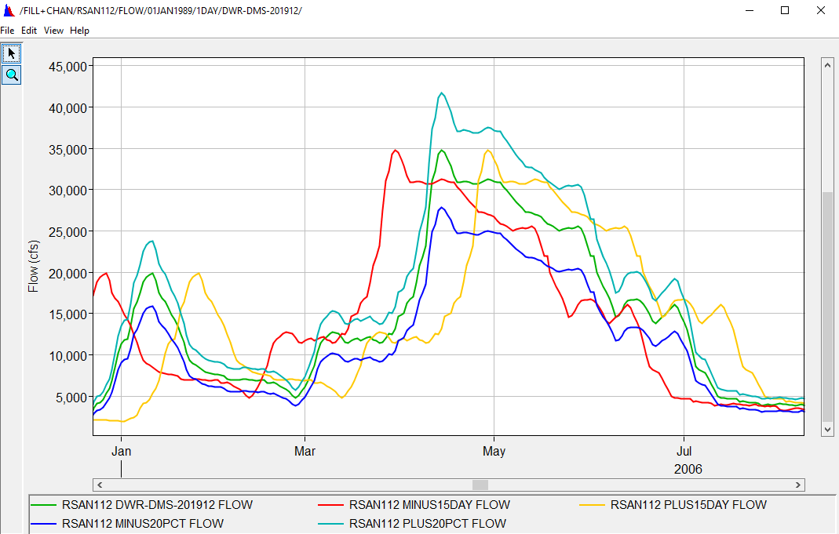

Outputs: Emmaton, Jersey Point and SWP Intake

Exceedance plots for EC are shown below (Period 1990-2019). "Cool" color tones represent Sacramento River inflow augmentations and "Warm" color tones represent San Joaquin River inflow augmentations.

* **Scaling flows in the Sacramento River produces the most impactful changes in DSM2** due to higher magnitudes of flow in Sacramento; in most cases RSACMINUS20PCT and RSACPLUS20PCT are the bookend scenarios.
* Shifting flows in Sac R. show increases in EC at 15-20% exceedance.

**Figure 3: Emmaton (EMM) EC Exceedance Probability**

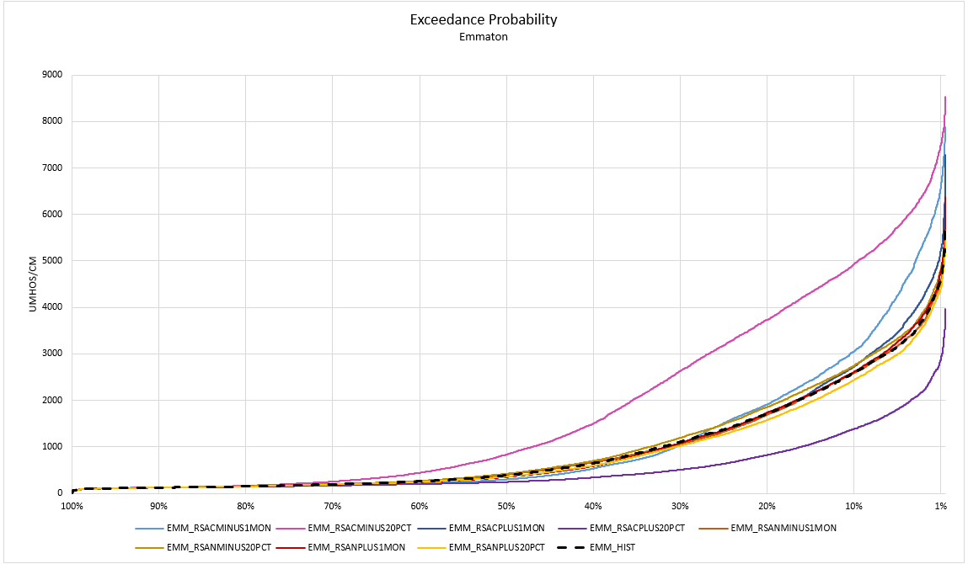

**Figure 4: Jersey Point (JER) EC Exceedance Probability**

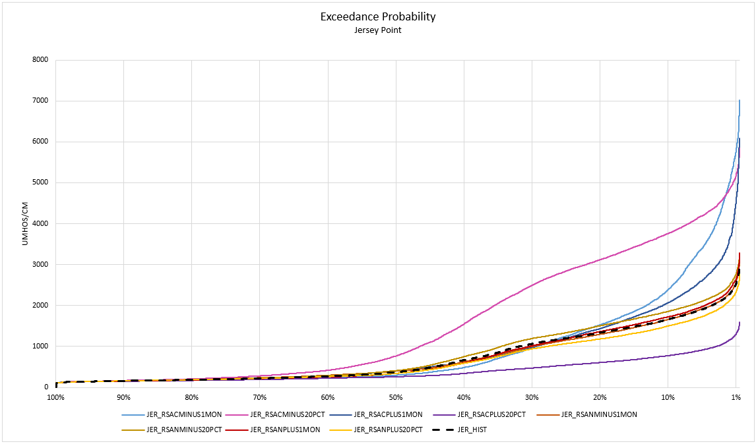

**Figure 5: SWP Banks Intake (CHSWP003) EC Exceedance Probability**

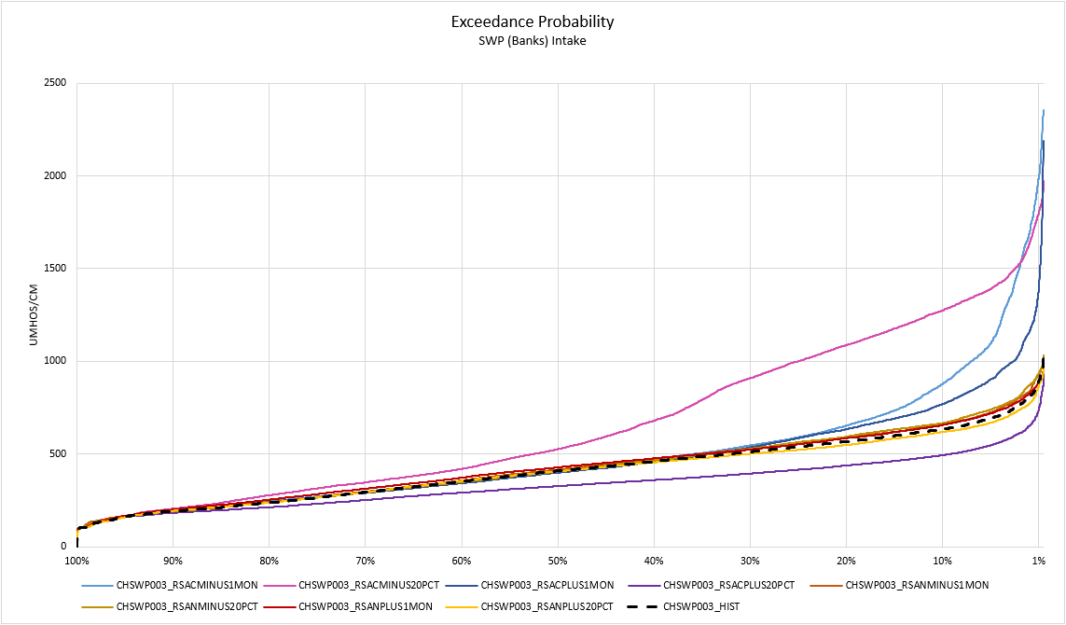

INPUTS: Augmentations to DSM2 Operation Timeseries

| **#** | **Scenario Alias** | **Description** |
| --- | --- | --- |
| 0 | Baseline | Historical with generated Martinez EC |
| 1 | DCC0 | Delta Cross Channel close |
| 2 | DCC1 | Delta Cross Channel open |
| 3 | SMSCG0 | Montezuma Slough Gate close |
| 4 | SMSCG1 | Montezuma Slough Gate open |

Delta Cross Channel

Output flow verification at channel 365 (after DCC) upstream daily

legend: baseline, DCC0, DCC1

* baseline has flow at seasonal opening time
* DCC0 has 0 flow
* DCC1 has flow all the time.

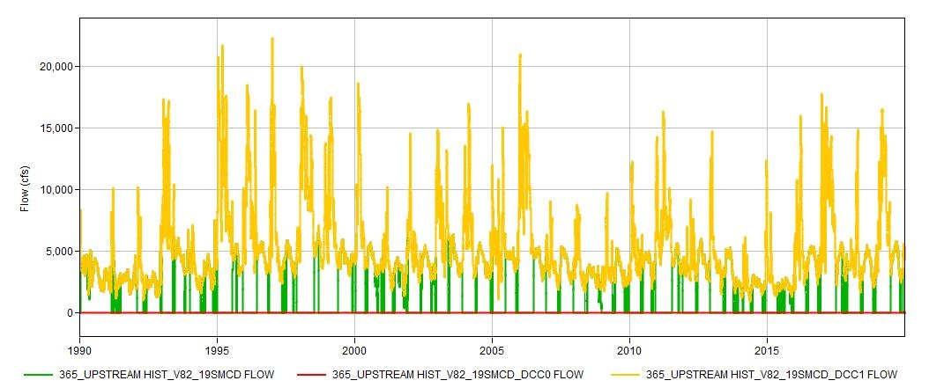

EC spot check downstream of DCC (RSAN032), compared to baseline

* DCC0 increase EC a lot (about 600)
* DCC1 lower EC a little bit

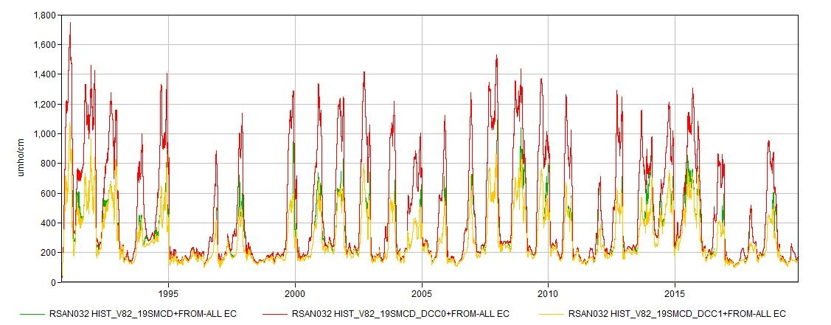

Montezuma Slough Salinity Control Gate

Output flow verification at channel 513 (after SMSCG) upstream daily

legend: baseline, SMSCG0, SMSCG1

* baseline has flow (tidally controlled) at seasonal opening time
* SMSCG0 has 0 flow
* SMSCG1 has tidal flow all the time.

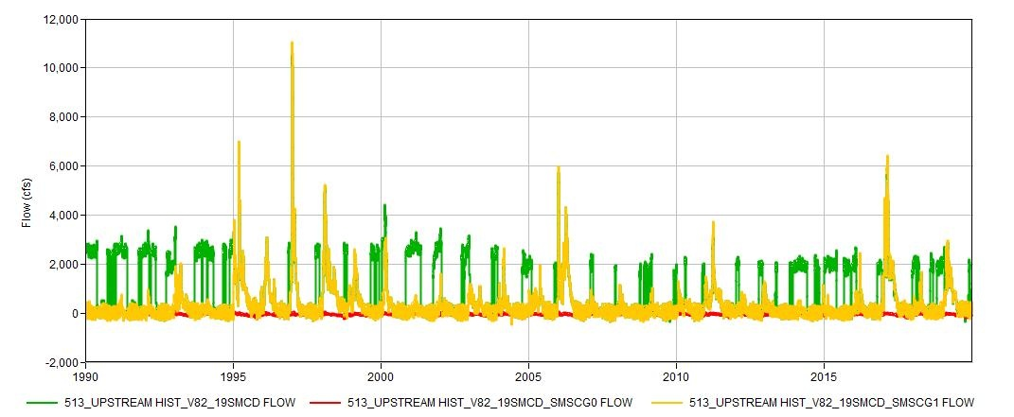

EC spot check downstream of SMSCG (SLMZU025), compared to baseline

* SMSCG0 increase EC a lot (about 5000)
* SMSCG1 increase EC a little (about 1000)

